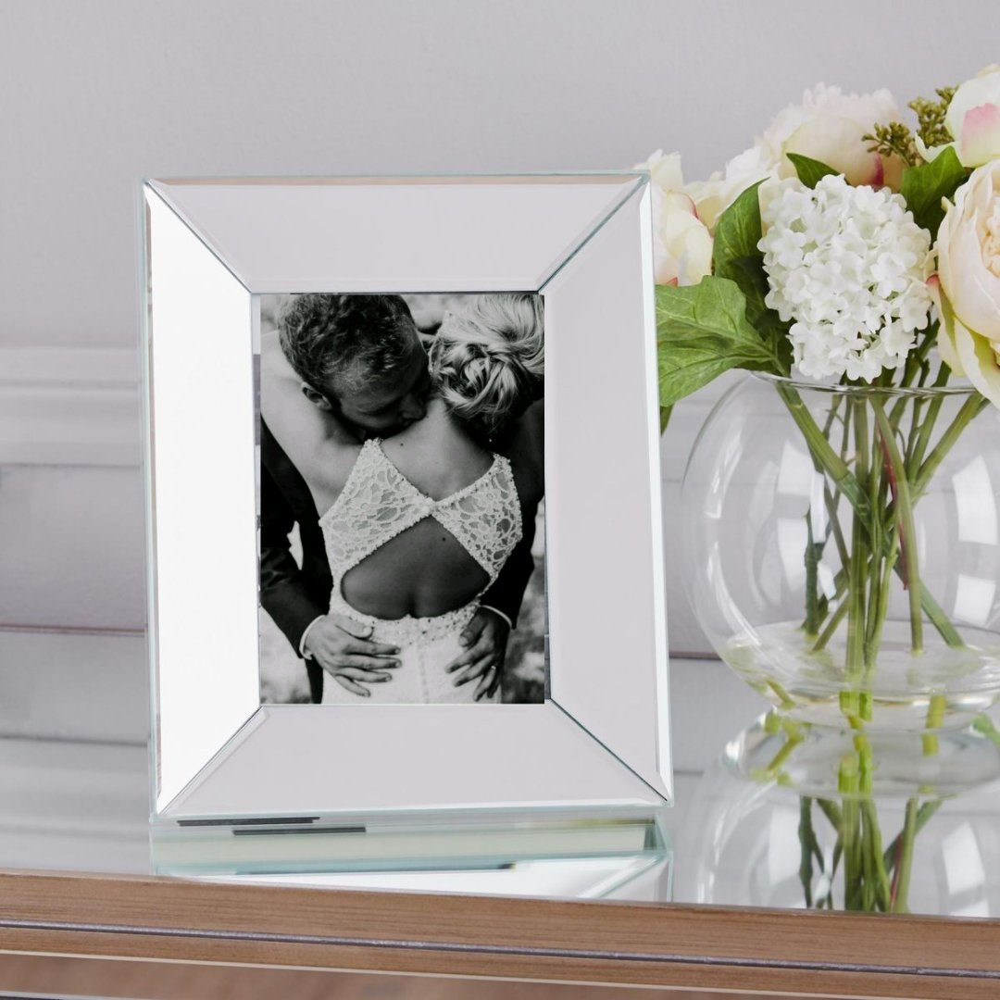
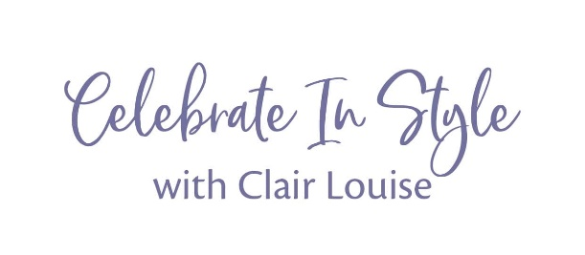

Online Spring Wedding Fayre – Booking Form

Sunday 25th April 2021 11:00am – 1:30pm

Our online wedding fayres will run a little differently to physical fayres, showing how fantastic our suppliers are in a more virtul format.

How it works.
Upon receiving an exhibition fee of £20.00, Images and a completed booking form, I will forward images to you for advertising use on any social media platform.
Prior to the event, each exhibitor will be advertised individually, in addition to then being listed as part of an over all listing of suppliers.
By the date specified, we will require a video which covers details of your business in the same way you would promote yourselves speaking to a couple at a venue fayre.
On the day your video and images/offers will be shown at a specified time of which you will be informed in advanced. This is when you will receive most of your contact as the video will give couples the chance to speak to you directly and ask any questions. Though the video links will be available for brides to go back to or watch again so you may receive enquiries later than your specified time as well.

What do you need to do?
Please fill in the information requested below and send back to admin@celebrateinstyle.co.uk, along with a selection of images and details of any offers/competitions you may want to include. The final date for applications is 28th February 2021.

Company Name:
Description (around 100 words advised)

Website Link:
Portfolio Link (optional)
Email Address:
Contact Number:
Facebook link:
Instagram Link:
Special Offer/Discount/ Incentive for couples (Please include and terms and conditions)

Terms and conditions.
We will do everything we can to accommodate you, should there be something that we can not provide for you, we will of course let you know as soon as possible.
Please kindly note that all bookings are confirmed once a signed booking form, terms and conditions along with full payment of either full balance or a 50% deposit is received. All bookings are on a first come first served basis. In order to ensure a variety of suppliers for our brides/grooms and there squads, spaces will be limited.
- All bookings are provisional until a completed booking form is received, along with a 50% deposit or full payment.
- Final balances are to be paid in full no later than 28 days before the event.
- Celebrate In Style – with Clair Louise accept no liability should the exhibitor not gain business and or sales from the event.
- Celebrate In Style – with Clair Louise reserve the right to postpone or cancel any event up to and including the morning of the scheduled event. In such an instance we will offer the option to transfer to another date when arranged or to another event, alternatively a full refund will available.

By Signing and returning this form you are agreeing to the above terms and conditions. *The above terms andconditions are set out in order to convey transparencywith what is expected of our exhibitors & in return, what our exhibitors can expect from ourselves.

Please fill in the above form and return via email - admin@celebrateinstyle.co.uk
Or via post to:
30 Sutton Drive
Doxey
Stafford
ST16 1UR

Payment should be made to
Celebrate In Style – with Clair Louise
Account Number - 13672877
Sort Code - 04 – 06 – 05

